What is Multimedia?
Multimedia can have a many definitions these include:

Multimedia means that computer information can be represented through audio, video, and animation in addition to traditional media (i.e., text, graphics drawings, images).
A good general definition is:
Multimedia is the field concerned with the computer-controlled integration of text, graphics, drawings, still and moving images (Video), animation, audio, and any other media where every type of information can be represented, stored, transmitted and processed digitally.
A Multimedia Application is an Application which uses a collection of multiple media sources e.g. text, graphics, images, sound/audio, animation and/or video.
Hypermedia can be considered as one of the multimedia applications.

What is HyperText and HyperMedia?
Hypertext is a text which contains links to other texts. The term was invented by Ted Nelson around 1965.
Hypertext is therefore usually non-linear (as indicated below).
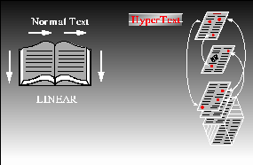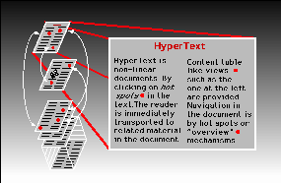
Definition of Hypertext
HyperMedia is not constrained to be text-based. It can include other media, e.g., graphics, images, and especially the continuous media - sound and video. Apparently, Ted Nelson was also the first to use this term.
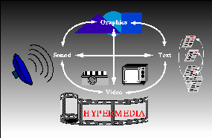
Definition of HyperMedia
The World Wide Web (WWW) is the best example of hypermedia applications.

Multimedia Systems
A Multimedia System is a system capable of processing multimedia data and applications.
A Multimedia System is characterised by the processing, storage, generation, manipulation and rendition of Multimedia information.

Characteristics of a Multimedia System
A Multimedia system has four basic characteristics:
- Multimedia systems must be computer controlled.
- Multimedia systems are integrated.
- The information they handle must be represented digitally.
- The interface to the final presentation of media is usually interactive.

Challenges for Multimedia Systems
Supporting multimedia applications over a computer network renders the application distributed. This will involve many special computing techniques -- discussed later.
Multimedia systems may have to render a variety of media at the same instant -- a distinction from normal applications. There is a temporal relationship between many forms of media (e.g. Video and Audio. There 2 are forms of problems here
- Sequencing within the media -- playing frames in correct order/time frame in video
- Synchronisation -- inter-media scheduling (e.g. Video and Audio). Lip synchronisation is clearly important for humans to watch playback of video and audio and even animation and audio. Ever tried watching an out of (lip) sync film for a long time?
The key issues multimedia systems need to deal with here are:
- How to represent and store temporal information.
- How to strictly maintain the temporal relationships on play back/retrieval
- What process are involved in the above.
Data has to represented digitally so many initial source of data needs to be digitise -- translated from analog source to digital representation. The will involve scanning (graphics, still images), sampling (audio/video) although digital cameras now exist for direct scene to digital capture of images and video.
The data is large several Mb easily for audio and video -- therefore storage, transfer (bandwidth) and processing overheads are high. Data compression techniques very common.

Multimedia Elements[edit]

The Five Multimedia Elements[edit]

Animation
Text, image, audio, video, and animation are the five multimedia elements. The first multimedia element is text. Text is the most common multimedia element. Text expresses the information the developer is trying to get across to their viewers. Even though pictures grab the viewers’ attention, text is a good idea to include, as well, just in case the picture does not load. The second multimedia element is image. An image catches the viewers’ attention much more quickly than just plain, old text. Almost every multimedia application contains images. The most common images are JPEGS and PNGs. Also, Photoshop and Paint.NET create high tech visual effects which are common with images. The third multimedia element is audio. Most of the time, audio files are deployed using plug-in media players. A few audio formats include RealAudio, MIDI, Wave, WMA, and MP3. The developer will compress the format to shorten the time. Before the file is downloaded, one can stream the audio. The fourth multimedia element is video. The web is the most common place where videos are seen concerning multimedia elements. A few digital video formats are Flash, MPEG, AVI, WMV, and QuickTime. Streaming digital videos can increase the speed of the playback. Developers use videos to hold on to the viewers’ attention. The fifth multimedia website is animation. Animation draws in the younger crowd. AdobeFlash is the most common tool for creating these animations. Animations are the most creative and fun multimedia element! [

JPEG, GIF, and PNG Formatting[edit]

Chameleon GIF
GIF and PNG are two different formats which images are available in. GIF simply means Graphics Interchange Format and is typically used for animations and sometimes single images as well. The images are compressed or made smaller; they are using what is called loss-less data compression. This compression makes it so that the image does not lose quality even if it is compressed due to its ability to have uniformed color with well-defined edges. A GIF is not the best quality format for images because of its limit of colors, which is one of the reasons that PNG was created. PNG are Portable Network Graphics. Their ability to compress is higher quality and allows for alpha transparency, which is basically creating the image with a background so that it looks transparent either partially or fully.^{[15]} They can store more color depth but also take up more space than GIFs in some cases. In cases where this does not apply it is because their ability to have better compression in 8-bit data ends up being smaller than GIFs.^{[16]} PNGs are unlike GIFs because they do not support animations, and are a single-image based format.^{[17]} These formats are used in many Web pages today and are both arguably as important.

Example of a .jpg image
The Joint Photographic Experts Group committee created the file format that is otherwise known as JPEG. JPEG is a technique and file format used to compress color images, digital photos, and other digital graphics. Many users who store photographs on their computer will recognize the JPEG file extension recognized as “.jpeg”, or “jpg”. The file size of a selected image can be optimized for different uses, otherwise known as editing a photo to the desired sizes. The file format does so by using a type of compression of the image known as “lossy compression”. The definition of lossy compression is defined as the ability for the image to decrease in file size, taking away a slight decrease in image quality. JPEG files are widely used by consumers as a way to save photos on their computer to view at their desire. However, a user may have interest in sharing these images through e-mail, or a website. As considering using a JPEG file on a website or through email, a user must consider the file size in comparison to the amount of quality of the image. For instance, if a user is interested in posting a photograph on a website of theirs, they must consider file size and formatting. Also, with e-mail, a user must consider the quality of the image they will be sending. The higher the quality of the image being sent, the larger the file size must be. If a user is sending this file over their cellular phone, it may require the use of more data to send a larger file size
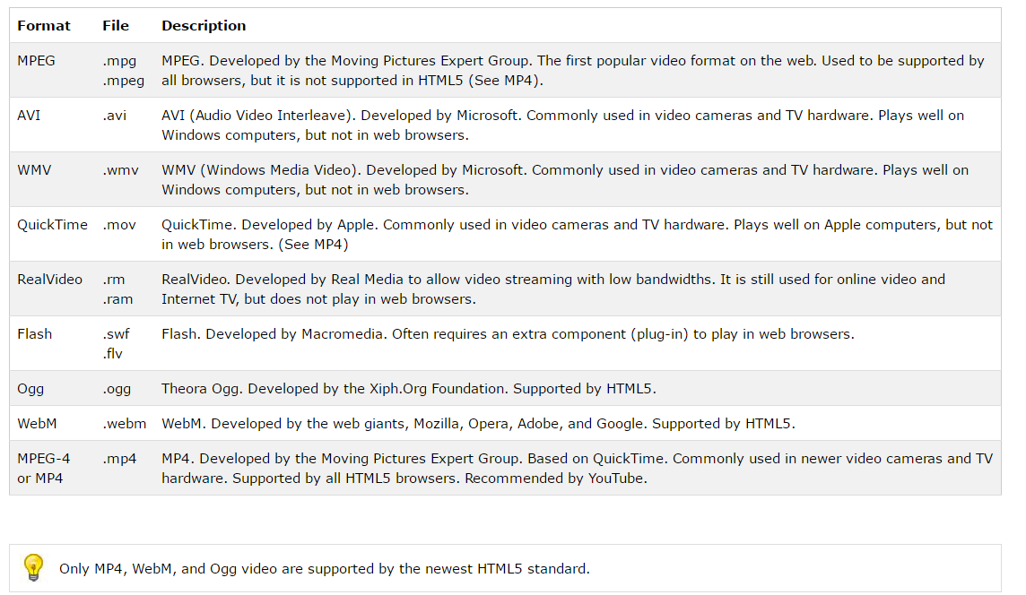
15-2 ELEMENTS OF MULTIMEDIA
If we break the word multimedia into its component parts ,we get multi -meaning more than one ,and media-meaning form of communication.Those types of media include:
. Text
. Audio Sound
. Static Graphics Images
. Animation
. Full-Motion Video
Let's look at each of these components in more detail.
1. Text
Whether or not they have used a computer ,most people are familiar with text. Text is the basis for word processing programs and is still the fundamental information used in many multimedia programs.
In fact ,many multimedia applications are based on the conversion of a book to a computerized form.This conversion gives the user immediate access to the text and lets him or her display pop-up windows , which give definitions of certain words.Multimedia applications also enable the user to instantly display information related to a certain topic that is being viewed.Most powerfully ,the computerized form of a book allows the user to look up information quickly (without referring to the index or table of contents).
The Windows operating environment gives the user an almost infinite range of expressing text.As a multimedia programmer ,you can choose what font to display text in ,how big (or small) it should be ,and what color it should be displayed in .By displaying text in more than one format ,the message a multimedia application is trying to portray can be made more understandable.
One type of application ,which many people use every day ,is the Windows Help Engine.This application is a text-based information viewer that makes accessing information related to a certain topic easy.
2. Audio Sound
The integration of audio sound into a multimedia application can provide the user with information not possible through any other method of communication .Some types of information can't be conveyed effectively without using sound.It is nearly impossible ,for example ,to provide an accurate textual description of the bear of a heart or the sound of the ocean.
Audio sound can also reinforce the user's understanding of information presented in another type of media.For example ,a narration might describe what is being seen in an animation clip.This can enhance the understanding of what the application is all about and lead to better comprehension.Experts in learning have found that presenting information using more than one sense aids in later retention of the information.Most importantly ,it can also make the information more interesting to the user.
Audio sound is available in several different formats.Today ,maybe the most common type of audio is red book audio.This is the standard specification used to refer to consumer audio compact discs.It is an international standard and is officially known as IEC 908.This specification is called red book audio because of the color of the cover of the publication that describes its formats.red book audio sound can also be used in multimedia applications ,and it forms the basis of the highest quality sound available.
Another audio sound format is the Windows wave file ,which can be played only on PCs running the Windows operating environment.A wave file contains the actual digital data used to play back the sound as well as a header that provides additional information about the resolution and playback rate.Wave files can store any type of sound that can be recorded by a microphone.
The final type of audio sound that may be used is known as the Musical Instrument Digital Interface ,or MIDI for short.The MIDI format is actually a specification invented by musical instrument manufacturers.Rather than being a digitized form of the sound ,the MIDI specification is actually a set of messages that describes what musical note is being played.The MIDI specification cannot store anything except in the form of musical notes.MIDI music can be created with a sequencer.
3. Static Graphics lmages
When you imagine graphics images you probably think of "still" images-that is ,images such as those in a photograph or drawing.There is no movement in these types of picture.Static graphics images are an important part of multimedia because humans are visually oriented.As the old Chinese proverb goes ,"A picture is worth a thousand words."Windows is also a visual environment.This makes displaying graphics images easier than it would be in a DOS-based environment.
Static graphics images have a number of formats and can be created in a number of different ways.Just as you can see an unlimited number of photographs or pictures ,the types of static graphics images that you can include in a multimedia application are almost unlimited.
4. Animation
Animation refers to moving graphics images.The movement of somebody giving CPR makes it much easier to learn cardiopulmonary resuscitation ,rather than just viewing a static picture.Just as a static graphics image is a powerful form of communication ,such is the case with animation.Animation is especially useful for illustrating concepts that involve movement.
Such concepts as playing a guitar or hitting a golf ball are difficult to illustrate using a single photograph ,or even a series of photographs ,and even more difficult to explain using text.Animation makes it easier to portray these aspects of your multimedia application.
5. Full-Motion Video
Full-motion video ,such as the images portrayed in a television ,can add even more to a multimedia application.Although full-motion video may sound like an ideal way to add a powerful message to a multimedia application ,it is nowhere near the quality you would expect after watching television.Full-motion video is still in its beginning stages on PCs ,and it is limited in resolution and size.Even with advanced methods of data compression ,full-motion video can suck up hard disk space faster than water falls when poured out of a bucket.
Right now ,there are two major methods of incorporating full-motion video into a multimedia application: Microsoft Video for Windows ,and Quick Time for Windows from Apple Computers.Both products come with tools for getting the video from an external input (a videocassette recorder or a video camera) and storing it on your hard disk drive.
6. All of the Above
You can see that multimedia is by on means just one of the preceding technologies.Because of what hardware can and cannot do ,it is often a trade-off between a certain number of static graphics images ,audio sound ,full-motion video and text.As you may guess ,textual information takes the least amount of space to store.
Even if a multimedia machine had unlimited resources ,you would still want to add a combination of these multimedia technologies.For example ,although a picture is worth a thousand words ,it would be difficult to portray the work of William Shakespeare through pictures only.The same goes for audio sound.You could record the sound of church bells and a narration of the Bible ,but at times you would rather have the Bible in textual format , which would allow you to search for certain keywords .

